* ADC 0809 is an 8 channel, 8 bit ADC. It can convert an analog voltage input into an 8 bit digital data output.
* To select an input out of 8 options, there are three select lines (C, B and A). We put a channel number on these lines (0…7) and latch it using ALE. SOC signal is given to indicate start of conversion.
* The channel voltage is internally sampled and held into a capacitor. Conversion takes place internally using “Successive Approximations Algorithm”.
* Reference voltage for conversion is provided using +Vref and –Vref. The clock supply needed for conversion is given through CLK (typically ~ 1MHz).
* The end of conversion is indicated by the ADC using EOC signal. Now we give the OE signal enabling 8-bit data output from the ADC to 8255.
* This data from 8255 is now transferred to the microprocessor. The process is repeated for subsequent channels, by changing the channel number. ADCs have a vast use in the modern electronic world for Data Acquisition Systems. They can be used for temperature sensing, voice recording, speed sensing etc.
* Interfacing of ADC 0809 with 8086 using 8255 is represented in figure below:

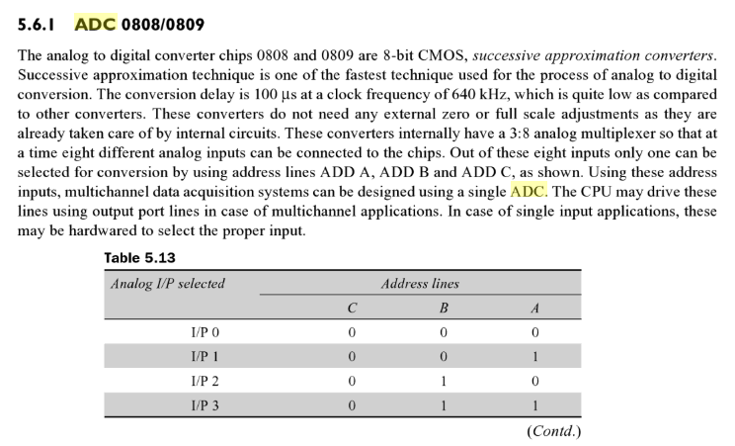

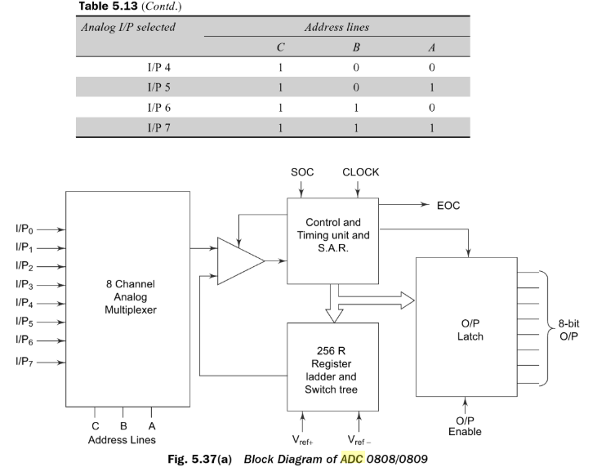

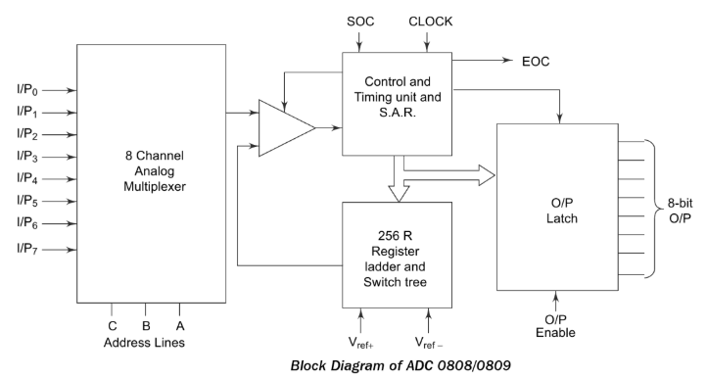

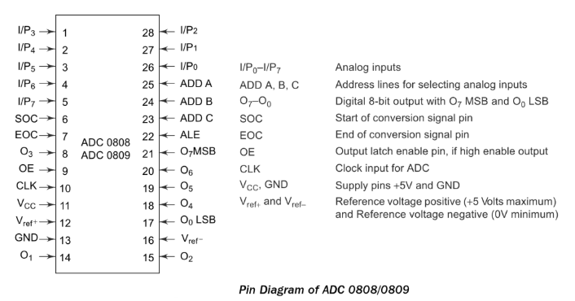

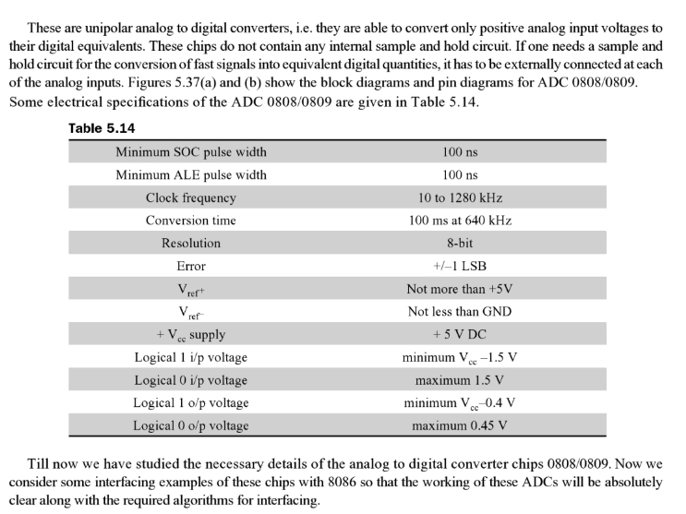

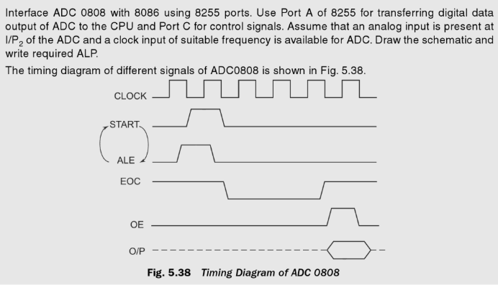

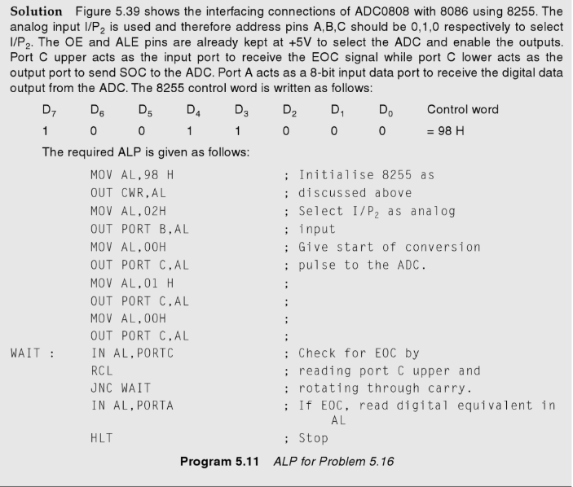

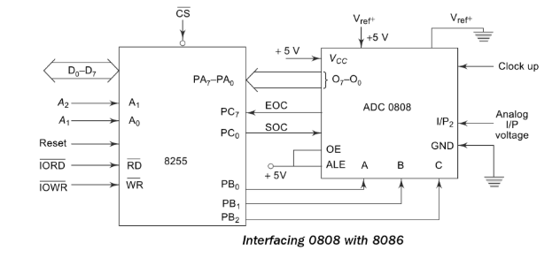

* DAC 0808 is an 8 bit Digital to Analog Converter. It can convert an 8 bit digital data input into an analog voltage output.
* Reference voltage for conversion is provided using +Vref and –Vref. The output can be amplified (optional) using an op-amp.
* DACs are used in various applications such as Waveform generation, PWM, Motor control Applications, DSP etc. Here we connect the output to a display device like a CRO.
* By simple programming we can generate several types of wave forms like Ramp, Saw-tooth, Triangular waveform etc.
* The output from 0808 DAC is current, so we need current to voltage converter at output of DAC as shown in figure below:

